9th Annual Rotman Accounting Research Conference
August 26-27, 2015

Rotman School of Management, University of Toronto
105 St. George Street
Toronto, ON, Canada

Organized by: Gus De Franco and Aida Sijamic Wahid
Sponsored by: Joseph L. Rotman School of Management
Wednesday, August 26th, 2015
Rotman School of Management, 105 St. George Street, Room 1065

12:15 – 12:45 | Registration and Refreshments
12:45 – 12:50 | Welcome and Opening Remarks
12:50 – 2:00 | Wayne Landsman  Paper: The Effects of CDS Trading Initiation on the Ownership Structure of Syndicated Loans
2:00 – 2:30 | Break
2:30 – 3:40 | Yonca Ertimur  Paper: Understanding Uncontested Director Elections: Determinants and Consequences
3:40 – 4:10 | Break
4:10 – 5:20 | Jim Naughton  Paper: How Does Algorithmic Trading Improve Market Quality?
6:30 – 10:00 | Reception & dinner @ Sassafraz

Thursday, August 27th, 2015
Rotman School of Management, 105 St. George Street, Room 1065

8:15 – 9:00 | Continental Breakfast
9:00 - 10:10 | Dawn Matsumoto  Paper: The effect of industry co-location on analysts’ information acquisition costs
10:10 - 10:40 | Break
10:40 - 11:50 | Minlei Ye  Paper: The Impact of PCAOB Type of Regulations on Auditors under Different Legal Systems
11:50 - 1:00 | Lunch
1:00 - 2:10 | Miguel Minutti-Meza  Paper: A Cross-Country Examination of Auditor Reporting for Going-Concern Uncertainty
2:10 - 2:40 | Break
2:40 - 3:50 | Luzi Hail  Paper: A Tale of Two Regulators: Risk Disclosures, Liquidity,  and Enforcement in the Banking Sector
3:50 – 4:00 | Concluding Remarks

Campus Map
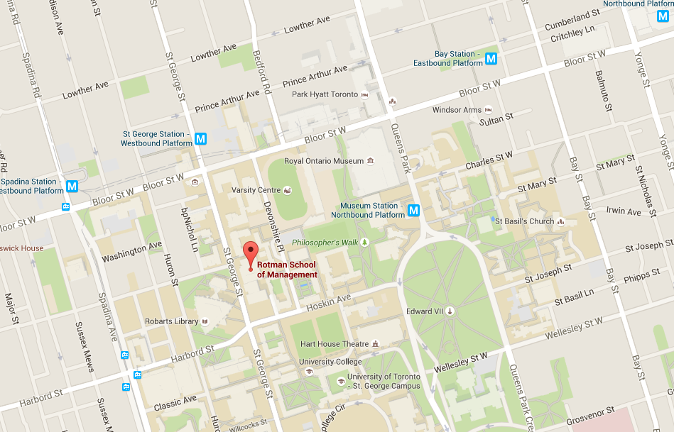
Sassafraz
Dinner Venue Location
Sassafraz
100 Cumberland Street

