Design Style Guide
February 2012

What is this Document?
This document is a reference to the PSDS used to create the Rotman website.
The Rotman School has set out to redesign business education for the 21st century and become one of the world's top-tier business schools. Located in the heart of Toronto -- North America's third-largest financial centre and one of the world's most culturally-diverse cities -- the School is developing an innovative curriculum built around Integrative Thinking™ and Business Design™. The School’s MBA program is now ranked in the top 15 in North America by the Financial Times. These are just some of the reasons why Bruce Nussbaum recently wrote in BusinessWeek Online, "Managers who want to 'get' the new innovation paradigm should check out [Rotman's] MBA and exec-ed programs."

Homepage - Homepage Banner
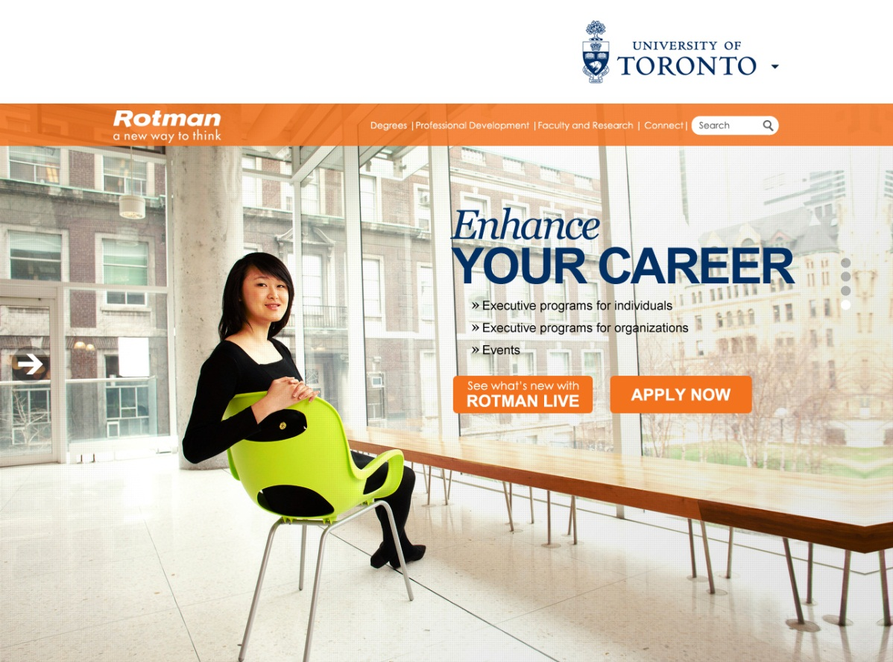
Size – 1285 x 1300 px
Resolution – 72 dpi
File type - .png, .jpeg, .gif

Subpage(s) - Subpage Banner
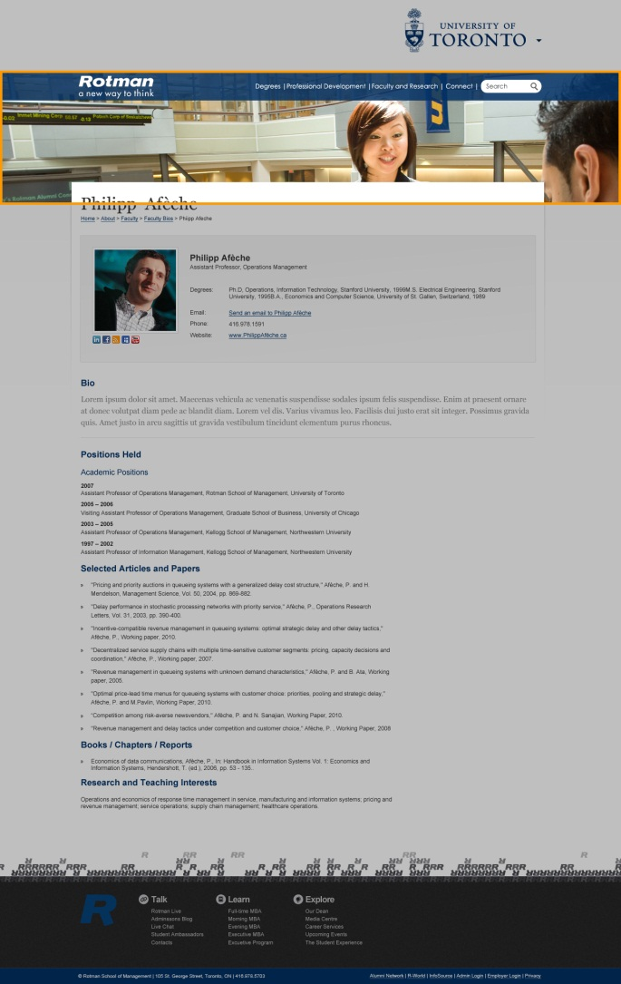
Size – 1285 x 277 px
Resolution – 72 dpi
File type - .png, .jpeg, .gif
*note: leave 62 pixels of negative space at the top and 48 pixels at the bottom of the image to allow for the blue bar and the overlapping of the content area

Subpage(s) - Light Box Banner
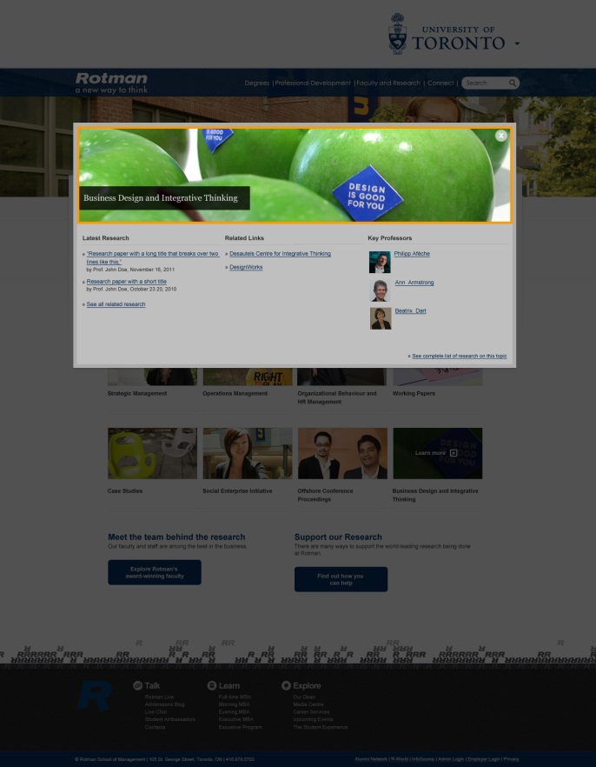
Size – 939 x 210 px
Resolution – 72 dpi
File type - .png, .jpeg, .gif

Subpage(s) - Callout
Size – 320 x 160 px
Resolution – 72 dpi
File type - .png, .jpeg, .gif
*note: leave 56 pixels of negative space at the bottom of the image to allow for the black bar

Subpage(s) - Small Callout
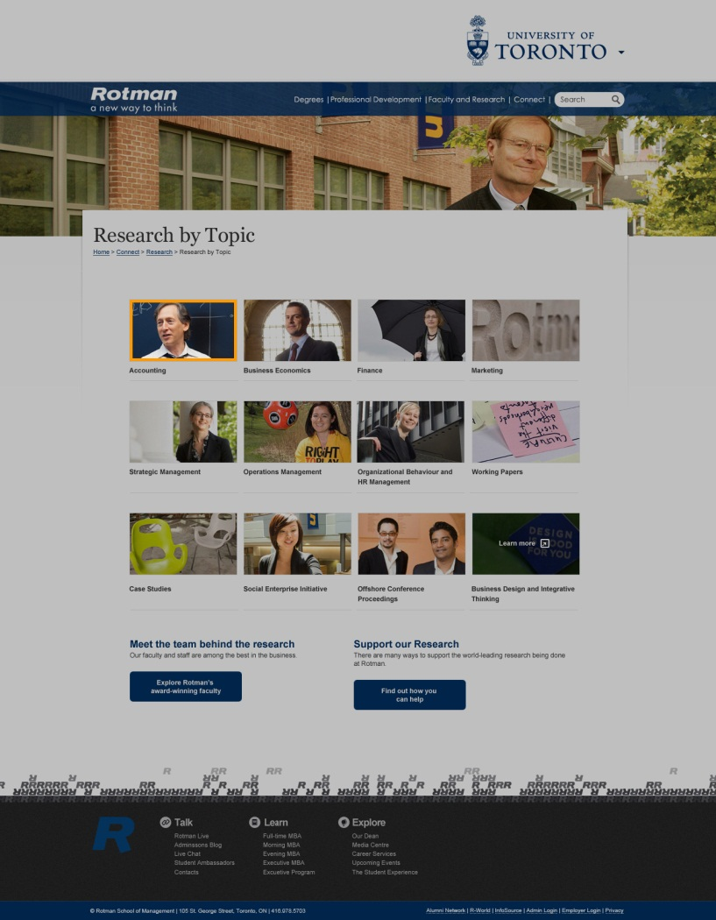
Size – 190 x 110 px
Resolution – 72 dpi
File type - .png, .jpeg, .gif

Subpage(s) - Bio Headshot - Small, Medium, Large

Smaller sizes are automatically generated by Sitecore

Size – 200 x 200 px
Resolution – 72 dpi
File type - .png, .jpeg, .gif

Subpage(s) - Thumbnail
Size – 165 x 80 px
Resolution – 72 dpi
File type - .png, .jpeg, .gif

Subpage(s) - Institute Header
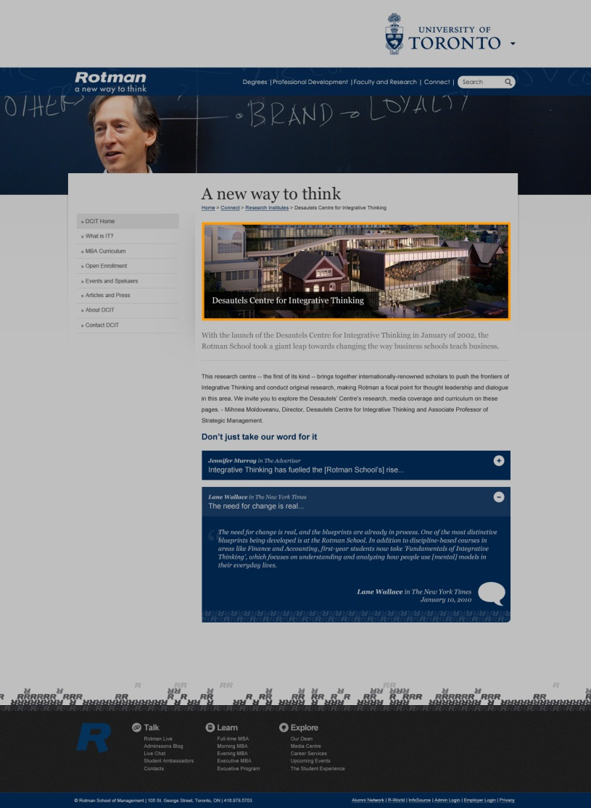
Size – 670 x 215 px
Resolution – 72 dpi
File type - .png, .jpeg, .gif

Image Sizes at a Glance

Subpage Banner: 1285 x 277 pixels
Light Box Banner: 939 x 210 pixels
Callout: 320 x 160 pixels
Small Callout: 190 x 110 pixels
Faculty Headshots: 200 x 200 pixels
Thumbnails: 165 x 80 pixels
Institute Headers: 670 x 215 pixels
Icons: 46 x 46 pixels
Rotman Primary & Secondary Colour Palette – RGB & HEX

Primary Palette
 |  | Rotman Blue | RGB – 0, 73, 144 | HEX - # 004990
 |  | Rotman Gold | RGB – 206, 157, 0 | HEX - #CE9D00
 |  | Rotman Grey | RBG – 124, 152, 174 | HEX - #7C98AE
Secondary Palette
 |  | Rotman Blue 30% | RGB – 165, 176, 211 | HEX - # A5B0D3
 |  | Rubine Red | RBG – 211, 0, 95 | HEX - #D3005F
 |  | Rotman Orange | RGB – 225, 115, 0 | HEX - #E17300
 |  | Rotman Yellow | RGB – 22, 224, 0 | HEX - #FCE000
 |  | Rotman Green | RGB – 98, 189, 25 | HEX - #62BD19
 |  | Rotman Sky Blue | RGB – 0, 194, 226 | HEX - #00C2E2

File Naming Convention

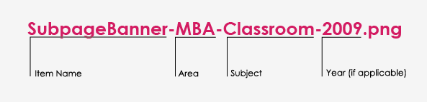

Website Sizing

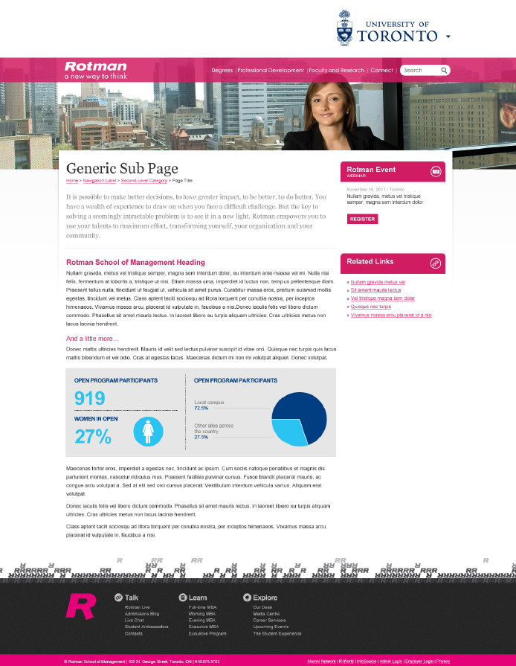
62 px
48 px
719 px
261 px
980 px

